|  |  |  |  |  |  |  |  |  |  |  |  |  |  |  |  |  |  |  |  |  |  |  |  |  |  |  |  |  |  |  |  |  |  |  |  |  |  |  |  |  |  |  |  |  |  |  |  |  |  |  |  |  |  |  |  |  |
| --- | --- | --- | --- | --- | --- | --- | --- | --- | --- | --- | --- | --- | --- | --- | --- | --- | --- | --- | --- | --- | --- | --- | --- | --- | --- | --- | --- | --- | --- | --- | --- | --- | --- | --- | --- | --- | --- | --- | --- | --- | --- | --- | --- | --- | --- | --- | --- | --- | --- | --- | --- | --- | --- | --- | --- | --- |
| logo    FACULTY OF COMPUTING AND INFORMATION TECHNOLOGY    Year 1  AACS1304 Systems Analysis and Design  2020/2021 (Semester 2)    Programme: ___________DCO1______________ Tutorial Group: Group 5   |  |  |  |  |  |  |  |  | | --- | --- | --- | --- | --- | --- | --- | --- | | Student Names | Student ID | Contribution (%) | Signature | Part 1 (30%) | Part 2 (20%) | Part 3  (10%) | Total (60%) | | TAN KANG HONG | 2002959 | 20 | TAN |  |  |  |  | | LAU JUN DIAN | 2003133 | 20 | DIAN |  |  |  |  | | HAR CHUN WAI | 2002982 | 20 | WAI |  |  |  |  | | LOW JUN YAN | 2003061 | 20 | YAN |  |  |  |  | | HO JING XIAN | 2002895 | 20 | XIAN |  |  |  |  | | Total: | | 100% |  |  |  |  |  |     Date of Submission: _____________    Date Received by Tutor: _____________  Comments: |

**Assessment Rubrics for Part 2.1: Final Documentation (Group)**

|  |  |  |  |  |  |  |
| --- | --- | --- | --- | --- | --- | --- |
| **Area** | **Criteria & Marks** | **Excellent** | **Good** | **Average** | **Poor** | **Score** |
| Content | Degree of completion and meeting assignment requirements.  Ability to develop a feasible report for a business system.  **(20 marks)** | Addressed all of  the assignment  components.  Very clearly  illustrated.  **(17 – 20)** | Addressed  almost all of the  assignment  components. It  is relatively  detailed.  **(12 – 16)** | Addressed many of the assignment  components.  Not detailed enough.  **(7 – 11)** | Does not address all  assignment  components.  Unclear.  **(0 – 6)** |  |
| Ability to apply knowledge, skills and critical understanding of the theories, concepts, issues and challenges in conducting a business project.  **(20 marks)** | Excellent in  applying  concepts learn.  **(17 – 20)** | Quite good in  applying  concepts learn.  **(12 – 16)** | Average in applying  concepts learn.  **(7 – 11)** | Poor in applying  concepts learn.  **(0 – 6)** |  |
| Points presented are correct and relevant to the topic.  **(20 marks)** | Perfectly  comprehensive,  relevant and  correct  description of  the assignment  deliverables.  All the  deliverables  have been  updated and  improved  accordingly.  **(17 – 20)** | Almost  comprehensive,  relevant and  mostly correct  description of  the assignment  deliverables.  Most  deliverables  have been  updated and  improved  accordingly.  **(12 – 16)** | Reasonably  correct  description of  the assignment  deliverables.  Some  deliverables  have been  updated and  improved  accordingly.  **(7 – 11)** | Unclear,  incorrect and  incomplete  description of  the assignment  deliverables.  Most deliverables  have not been  updated and  improved  accordingly.  **(0 – 6)** |  |
| Presentation Format | Points are logically developed (easy-to-read).  **(5 marks)** | All the points  are logically  developed with  excellent structure.  **(5)** | Most of the  points are logically  developed with  adequate structure.    **(4)** | Some of the  points are not  logically  developed and  have awkward  structure.  **(3)** | Most of the  points are not logically  developed. Very  poor structure.  **(0 – 2)** |  |
| Compliance with prescribed formatting requirements.  **(5 marks)** | Professionally formatted and  meeting all  formatting  requirements.  **(5)** | Clear and recognizable format and meeting almost of the formatting requirements.  **(4)** | Recognizable format and meeting some of the formatting requirements.    **(3)** | Little attempt to use the appropriate format.  **(0 – 2)** |  |
| **Total** | **70** |  |  |  |  |  |

Assessment Rubrics for Part 2.2: Final Presentation - Oral (Individual)

|  |  |  |  |  |  |  |  |  |  |  |
| --- | --- | --- | --- | --- | --- | --- | --- | --- | --- | --- |
| **Area** | **Criteria & Marks** | **Excellent** | **Good** | **Average** | **Poor** | **Student Name** | | | | |
|  |  |  |  |  |
| Content | Viewpoints logically  developed and  completed  **(10 marks)** | Viewpoints logically developed. Complete and very clear explanation of content.  **(9 – 10)** | Viewpoints fairly developed. Adequate explanation of  content.  **(6 – 8)** | Viewpoints poorly developed. Unclear  Explanation of  content.  **(3 – 5)** | Viewpoints not logically developed. Lack of explanation of content.  **(0 – 2)** |  |  |  |  |  |
| Effective and correct application of concepts  **(10 marks)** | Captivating and interesting. All are appropriate and effective.  **(9 – 10)** | Most parts are interesting.  Mostly are appropriate and effective.  **(6 – 8)** | Some parts are interesting. Some are appropriate and  effective.  **(3 – 5)** | Most parts are boring and uninteresting. All are not appropriate and effective.  **(0 – 2)** |  |  |  |  |  |
| Delivery & Style | Clarity of presentation & explanation  **(5 marks)** | Highly effective oral  communication skills. Hardly reading from text.  **(5)** | Effective oral communication skills.  Occasionally reading from text.  **(4)** | Average oral communication skills.  Frequently reading from text.  **(3)** | Poor oral  communication  skills. Most of the time reading from text.  **(0 – 2)** |  |  |  |  |  |
| Demonstrated understanding (handling Q & A)  **(5 marks)** | Able to handle all the Q & A. All explanations are accurate and clear.  **(5)** | Able to handle most of the Q & A. Most explanations are accurate and clear.  **(4)** | Able to handle some Q & A. Some  explanations are inaccurate and confusing.  **(3)** | Unable to handle any Q & A. All explanations are inaccurate and confusing.  **(0 – 2)** |  |  |  |  |  |
| **Total** | **30** |  |  |  |  |  |  |  |  |  |

*Total of 100% (Part A and B) is to be converted to 20% as the final coursework mark.

**Comment by tutor (if any)**:

________________________________________________________________________________________________________________________________________________________________________________________________________________________________________________________________________________________________________________________________________________________________________________________________________________________________________________________________________________________________________________________________________________________________________________________________________________________________________________________________________

**Assessment Rubrics for Part 3: Leadership and Team Work – Individual (10%)**

|  |  |  |  |  |  |  |  |  |  |
| --- | --- | --- | --- | --- | --- | --- | --- | --- | --- |
| **Criteria & Marks** | **Excellent** | **Good** | **Average** | **Poor** | **Student Name** | | | | |
|  |  |  |  |  |
| Demonstrate leadership skills in team-related tasks.  **(25 marks)** | 21 - 25 | 15 - 20 | 8 - 14 | 0 - 7 |  |  |  |  |  |
| Support and respect team members’ opinions and ideas during team-related tasks.  **(25 marks)** | 21 - 25 | 15 - 20 | 8 - 14 | 0 - 7 |  |  |  |  |  |
| Communicate, manage information, manage time, manage resources and engage harmoniously with others.  **(25 marks)** | 21 - 25 | 15 - 20 | 8 - 14 | 0 - 7 |  |  |  |  |  |
| Cooperate in a team to implement systems development activities based on a given business requirement.  **(25 marks)** | 21 - 25 | 15 - 20 | 8 - 14 | 0 - 7 |  |  |  |  |  |
| **100** |  |  |  |  |  |  |  |  |  |

**Comment by tutor (if any)**:

________________________________________________________________________________________________________________________________________________________________________________________________________________________________________________________________________________________________________________________________________________________________________________________________________________________________________________________________________________________________________________________________________________________________________________________________________________________________________________________________________

# **Table of Contents**

|  |  |  |
| --- | --- | --- |
| **No.** | **Contents** | **Page No.** |
| 1 | Introduction | 10 |
| 2 | Task 1: Case Study – Organization Background  1.1 Introduction  1.2 Product and services  1.3 Business Services  1.4 Organization Structure  1.5 Current System Used | 11  12-13  14-15  16-18  19-20 |
| 3 | Task 2: System Planning – Preliminary Investigation  2.1 System Request Form  2.2 Reason of Request  2.3 Services Requested | 21-22  23  24 |
| 4 | Task 3: System Planning – Feasibility Study  3.1.1 Hardware Cost  3.1.2 Software Cost  3.1.3 Software Development  3.1.4 Implementation  3.1.5 Operating Cost  3.1.6 Cost Summary  3.2 Benefits Summary  3.3 Intangible Benefits | 26-30  31-33  34  34  34  34  34  35 |
| 5 | Task 4: System Planning – Fact Gathering  4.1 Interview Questions  4.2 Questionnaires | 36-37  38-40 |
| 6 | Task 5: System Analysis – Fact Recording  5.1 Context Diagram  5.2 Diagram 0 DFD  5.3 Diagram 1 DFD – Return book and calculate day exceed  5.4 Entity Relationship Diagram (ERD) | 41  42  43  44 |
| 7 | Task 6: System Design – Functional Design  6.1 Functional Design  6.2 Functions and Features | 45  46-47 |
| 8 | Task 7: System Design – Inputs  7.1 Data input screen  7.2 Characteristics of user-friendly interface  7.3 Validation Check | 48-49  49-50  51-52 |
| 9 | Task 8: System Design – Data Definition  8.1 Attributes and Keys  8.2 Develop Database Design Language (DBDL) | 53  54 |
| 10 | Task 9: System Design – Database  9.1 Code Design  9.2 Data Records  9.3 Database Design | 55-57  57-61  62-63 |
| 11 | Task 10: System Design – Outputs / Reports  10.1 Table of Reports  10.2 Detail Report  10.3 Exception Report  10.4 Summary Report  10.5 Principles of Good Report Design | 64  65  66  67  68 |
| 12 | References | 69 |
| 13 | Appendix | 70-72 |

# **Introduction**

The System Development Life Cycle (SDLC) is an organized approach that used to develop an information system. It also represents a complete life cycle of a system. There are six phases that the company must follow in order to develop a system, this includes System Planning, System Analysis, System Design, System Development, System Implementation and Operation and Maintenance. The main objective of this assignment is to let us know how to apply the concepts of System Analysis and Design that we have studied into the case study. In this case study assignment, the system that we proposed is a library system.

# **Task 1: Case Study – Organization Background**

## 1.1 Introduction

Tun Rahman Abdul College (TRAC) was founded in 1970. Its purpose is to provide higher education chances for young Malaysians (regardless of their race) to seek quality education and meet the human capital needs of businesses and industries. The college first started on a campus in Starpak, Kuala Lumpur and is now the main campus.

Kuala Lumpur’s TRAC (main campus) is located on 200 acres of land. At the same time, branch schools in Penang, Perak, Johor, and Pahang are specially built, with the most advanced infrastructure and learning and teaching facilities. Looking ahead, it is planned to establish another new TRAC dedicated campus in Sabah.

The courses offered by TRAC include pre-university courses, diploma courses, bachelor's degree courses and postgraduate courses. These courses and rigorous academic research have been widely recognized by academia and industry. Now, TRAC has gone from basic and A Level to accounting, finance, business, economics, engineering, built environment, applied sciences, ICT and mass communication, creative arts, social sciences and hotel management.

These courses are implemented by 7 colleges and 1 center (Ex: University Preparatory Research Center, Faculty of Accounting, Finance and Business, Faculty of Applied Science, Faculty of Computer and Information Technology, Faculty of Engineering and Technology and Faculty of Built Environment) to implement exchanges and creativity Faculty of Industry and Social Sciences and Humanities. In addition, there is a graduate research center dedicated to research.

TRAC has won numerous academic awards, among which the most prestigious awards include: the 2017 top digital technology colleges selected by the Ministry of Higher Education and the Malaysian Digital Economy Corporation ('MDEC'), and the 2016 Asia Pacific Corporate Social Awards Responsibility Award. Educational Improvement Excellence Award.

## 1.2 Product and Services

### **Outdoor Facilities**

TRAC have provided several outdoor facilities such as football field, softball pitch, jogging track, futsal courts, handball courts, basketball courts, volleyball courts, rooftop tennis courts and outdoor gymnasium.

Its opening hours for weekdays (Monday to Friday) are from 9:00am to10:00pm and for weekends (Saturday and Sunday) are from 9:00am to 7:00pm. Besides, these outdoor facilities will be closed in Public Holidays.

### **Indoor Facilities**

TRAC also have provided indoor facilities for the staff and students. For instance, the Sports Complex consists of gymnasium, multipurpose hall, dancing room, badminton courts and table tennis courts.

Its opening hours for weekdays (Monday to Friday) are from 9:00am to7:00pm and for weekends (Saturday and Sunday) are from 9:00am to 1:00pm. Besides, these indoor facilities will be closed in Public Holidays.

### **Academic Facilities**

Academic Facilities such as Integrated Innovation Hub (I2 Hub), Student Career Development Centre (SCDC), Library, Cyber Centre, IBM Centre of Excellence, Investment share trading room, Broadcast laboratories and studios, Video and audio lab, Photography studio, News room, Multimedia labs, Sports and exercise science labs, Physics labs, Networking lounge, Pitching hall and Co-working Space are also provided and available for use by TRAC.

### **Computing Facilities**

TRAC have also provided computing facilities such as Wi-Fi hotspots in several places all over the university, including libraries and canteens.

### **Campus Facilities**

#### **On-campus hostel**

TRAC hostel consists of 6-storey 9 blocks building with 850 standard rooms that can live up to 1800 students. Each room can be shared by up to 2 students, including 900 men and 900 women. Each room also provided with personal public bathroom, toilet, pantry, water dispenser and drying area.

#### **Off-campus accommodation**

The student dormitory is 30 floors high and consists of 500 units. Each unit consists of 4 air-conditioned or non-air-conditioned rooms. This student dormitory can occupy up to 180 students. The facilities provided by the student dormitory includes gymnasiums, swimming pool, multi-purpose hall, barbecue area, cafeteria, study room, convenience store, hot/cold water dispenser, self-service laundry and Surau. Each unit is also equipped with bathroom, toilet, pantry, refrigerator, induction cooker, sofa, flat-screen TV, shoe rack and drying area, as well as a bed, cupboard, study table, chair, bookshelf and ceiling fan.

### **Transportation**

TRAC’s air-conditioned bus can transport students between the Kuala Lumpur main campus and nearby residential areas, as well as light rail stations.

### **Programs and Certificates**

TRAC has been prepared with the most professional courses for students to learn from. TRAC offers programs in postgraduate programs, undergraduate programs and Pre-University programs. TRAC also provided several certificates such as Certificate in Diploma, Degree, Master and Doctor.

## 1.3 Business and Operation

### **Size of business and operation**

TRAC is large-size of business of operation. TRAC started with a single campus in Starpak, Kuala Lumpur which is now the Main Campus. Afterwards, five branches campuses were established in Penang, Perak, Johor, Pahang and Sabah. As we all know Malaysia private university was very famous around the world. Every year a lot of international students come to our country to study university. In Malaysia, TRAC always the most cheaper and complete resource allocation. TRAC also prepare professional lecturers to our dear students. TRAC lecturers came from the world’s famous university graduated. In addition, TRAC account was the most famous in the world, some of the university were bought our examination paper. In last year, TRAC student get the highest mark in the world, the paper was ACCA. TRAC was pay attention in library, because students need a well and good place to study well. In University Management, they always pay attention to listen from students' feedback and improve library.

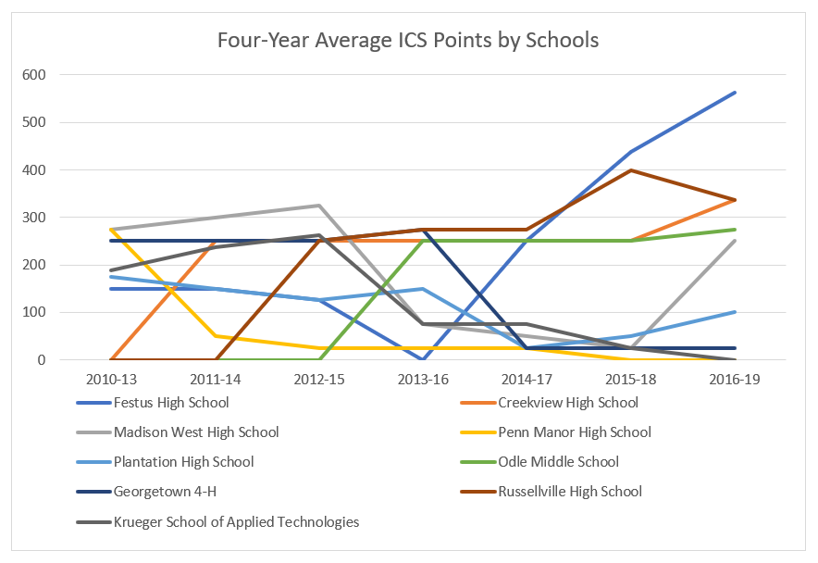

Diagram 1.3.1 TRAC University College Ranking in Malaysia

### **Customers**

TRAC has a student population of about 28000 including international students from more than 20 countries. TRAC is one of the oldest institutions of higher learning in Malaysia with more than 190000 students that have already passed the requirement of being a TRAC students with at least 3 credits and not failing Bahasa Melayu subject. Also, TRAC ranking are higher than other university and colleges. TRAC provide scholarship to all great student. Most students join our society to get more experience. TRAC also provide 200++ programme to those join our university. TRAC was certified by MQA Malaysia, it can improve student knowledge and join the competition in Malaysia. From here, TRAC was a good reputation that have already passed the requirement of being a TRAC students with at least 3 credits and not failing Bahasa Melayu subject. Also, TRAC ranking are higher than other university and colleges. TRAC provide scholarship to all great student. Most students join our society to get more experience. TRAC also provide 200++ programme to those join our university. From here, TRAC was a good reputation in Malaysia.

### **Suppliers**

TRAC have many department and course that had been started. There are some suppliers which provide TRAC supplies such as Apple reseller, Google, Telekom Malaysia, Cisco and etc. Some of the suppliers will supply books, furniture and etc. TRAC supplier also help us to build up our environment. Most of the library’s books are supply by another university and book reseller. Besides, we also got supply from cisco for those IT students to get more knowledge in it. Apple reseller supply computer to TRAC and service TRAC computer. Google supply TRAC server and motivate to University and college. Telekom Malysia supply TRAC internet Wi-Fi and Internet service. Cisco is an education in Malaysia where IT students who study at TRAC will join this course.

   

### **Competitors in the market**

TRAC becomes one of the most famous libraries in Malaysia. Because of this, TRAC has more and more competitors with its reputation. Such as Sunway University, Taylor University, UCSI University, Monash University and etc.

## 1.4 Organization Structure

The organizational structure groups the employees according to department functions. TRAC’s organizational structure is used to let employees know who are they direct in charge to, so that employees can report their work to superior, and managers can summarize them and report to senior management. The organizational structure shows us that employees are grouped by vertical level. For TRAC, it has been divided into several departments such as examination department, a library department, a bursary department, human resource department and registry department.

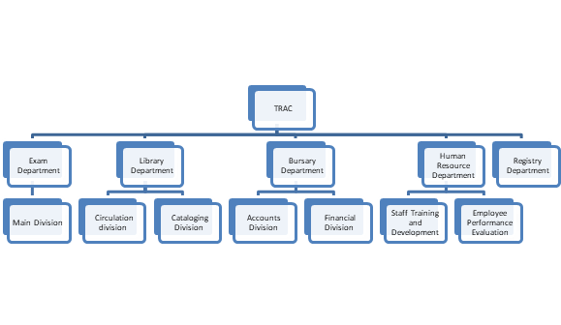

### **Functions of each Department**

|  |  |  |
| --- | --- | --- |
| **Department** | **Division** | **Functions** |
| Exam Department | Main Division | The aim of this department is to formulate, legalize and determine valid examinations and examinations for various education, conduct and manage naturalization examinations, conduct examinations for supervision and inspection agencies, and produce and distribute examinations. |
| Library Department | Cataloging Division | Cataloging is aim to provide access to library materials by creating records of books, serial numbers, video records, sound recordings, software electronic resources and other types of information in the library in the catalog. |
| Circulation Division | The main station of public services is the circulation desk or the borrowing desk, usually near the main entrance of the library. It provides lending services and facilities for returning lent items. Update information and payment of fines can also be made at the circulation counter. Staff can provide basic search and reference services, although they usually introduce more in-depth questions to reference librarians at the library information desk. In most cases, the distribution desk is handled by library support staff rather than professional librarians. |
| Bursary Department | Accounts Division | The main purpose of the accounts division is to organize and keep accounting records of all transactions conducted in the university organizational unit in accordance with applicable regulations as well as to settle payments and scholarships for students. |
| Financial Division | The aim of finance is to handle banking business, to handle cash transactions, to resolve employee advance payments and expense claims arising from business travel, and to cooperate with banks with university bank accounts to open cash desks. |
| Human Resource Department | Staff Training and Development | The personnel department should also implement training programs to ensure the growth of each employee of the company and the development of key skills for the company in the future. This is not only a way to attract and retain talent, but also to maximize the potential of human capital. Organizing courses, training, establishing career paths and internal promotions are key tasks of human resources. |
| Employee Performance Evaluation | The performance of each employee and his commitment to the company should be regularly evaluated. For each member of the organization, specific and measurable goals and a pre-established evaluation system are critical to this process. |
| Registry Department | - | The registry is the college’s secretariat and the center and meeting point for all administrative activities of the university. The registry is led by the registrar. In order to enable the registry as a department to operate smoothly and effectively, it is now divided into the general office of the registry, the board affairs department, the personnel department and the academic affairs department. In addition to participating in the formulation and implementation of college policies, the main office of the registry is also responsible for coordinating the activities of other departments. |

## 1.5 Current Systems Used

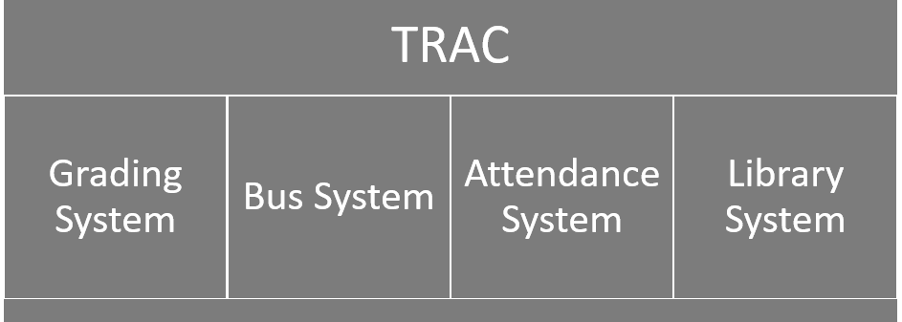

### **Functions of each Department**

TRAC has been very famous thanks to its outstanding library system provided to their students. Library system allows students to borrow, return, renew and make the payment through online or TRAC mobile app. This system will also enable students easier to search the catalog for books, magazines, journals, digital media and browse library resources effortlessly. Student can also easily view borrowed and returned books, put them on hold, and request or renew books. After reading the book, student can provide reviews and give ratings to books.

### **Grading System**

Grading system is used by school to assess students’ educational performance. Grades can be specified by letters, such as A-F, by range such as 1-4, and also by number such as out of 100. In TRAC, grades are averaged to create a cumulative grade point average (CGPA) to measure student’s performance in all course.

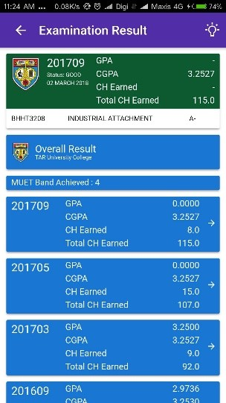 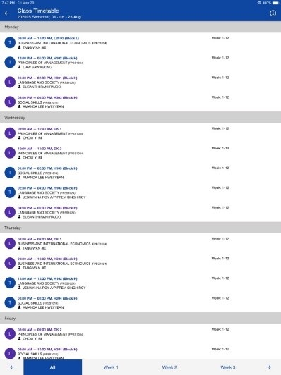

### **Bus System**

Bus system is a way to helps students, staff and teachers manage transportation options to and from school. This is also a better way to ensure student safety and security and this is the top most priority of every school administrators. With Bus system, parents can easily track on the movement of buses, its locations and routing to have a complete overview of their child movement.

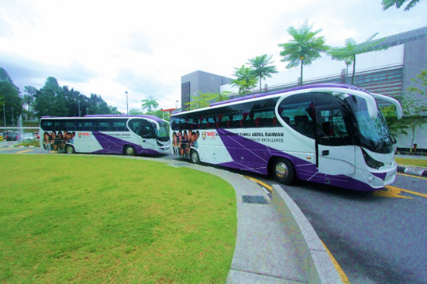 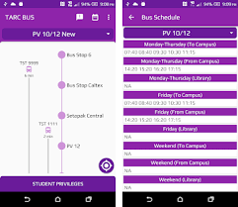

### **Attendance System**

TRAC also provide the attendance system for academic classes and also co-curricular sessions. Students can use the TRAC mobile app with any Wi-Fi or hotspots in TRAC connected to check-in while attending classes. Students can also check their attendance history in the mobile app anytime.

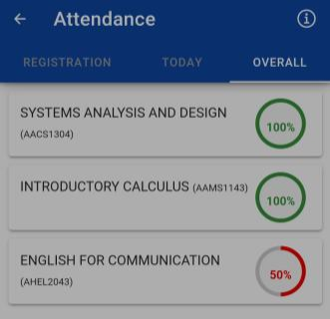

# **Task 2: System Planning – Preliminary Investigation**

## 2.1.1 System Request Form

|  |  |  |  |  |  |  |  |  |  |  |  |  |  |  |  |  |  |  |  |  |  |  |  |  |  |  |  |  |  |  |  |  |  |  |  |  |  |  |  |  |  |  |  |  |  |  |  |
| --- | --- | --- | --- | --- | --- | --- | --- | --- | --- | --- | --- | --- | --- | --- | --- | --- | --- | --- | --- | --- | --- | --- | --- | --- | --- | --- | --- | --- | --- | --- | --- | --- | --- | --- | --- | --- | --- | --- | --- | --- | --- | --- | --- | --- | --- | --- | --- |
| **TRAC College**    **Request for System Services**   |  |  |  |  | | --- | --- | --- | --- | | **(1)**  **Date:**2/11/2020 | | **(4)**  **Department:**Library | | | **(2)**  **Submitted by:**  Head of Library Department, Justin | | **(5)**  **Location:**5, Jalan University, Bandar Sunway, 47500 Puchong, Selangor. | | | **(3)**  **Title:**Upgrade current system | | **(6)**  **Email:**justin@trac.com | | | **(7)**  **Type of Request:** | |  |  | | --- | --- | |  | **New System** | |  | **System Maintenance** | | **✔** | **System Enhancement** | |  | **Immediate attention required** | |  | **Handle in normal priority sequence** | |  | **Defer until new system is developed** | | | **(8)**  **Urgency**   |  |  | | --- | --- | |  | **Low** | | **✔** | **Medium** | |  | **High** | |  |  | | --- | | **(9)**  **Brief statement of Problems / Reasons for Requested:**  Recently, a lot of user complain about the system is old and slow as they can't efficiently complete their task especially when using the computer in the library. So, the system in the library may need to be upgraded so the system can run smoothly. | | **(10)**  **Brief statement of expected solution / Services Requested:**  I suggest that we can improve our server so user can do their task more easily. |   **(11) Action**   |  |  |  | | --- | --- | --- | | **✔** | **Request Approved** | **(12) Assigned to IT contact person: Jason** | |  | **Request Rejected** | **(13) Urgency code:   low / medium / high** | |  | **Request Delayed** | **(14) Reason (if needed): -** |  |  |  | | --- | --- | | **(15) Signature: Jason** | **(16) Date:** 5/11/2020 | |

## 2.1.2 Description

|  |  |
| --- | --- |
| **No** | **Functions** |
| 1 | The date when the form filled up. |
| 2 | The applicant’s name. |
| 3 | The name ofthe issues. |
| 4 | The department where the issues detected. |
| 5 | The location where the issues detected. |
| 6 | The applicant’s email. |
| 7 | The applicant chooses the request issues. |
| 8 | The applicant determines the urgency level of the issues. |
| 9 | The applicant describes in details about the request issues. |
| 10 | The applicant describes in details about the expected solution. |
| 11 | To let the IT department to verify the approval of the request. |
| 12 | The name of the person who received the request form in IT department. |
| 13 | To let IT department determines the urgency level of the issues. |
| 14 | The reason if the request is delayed or rejected. |
| 15 | The signature of the person who received the request form in IT department. |
| 16 | The date when the IT department received the request form. |

## 2.2 Reason of Request

### **1) Slow response**

Likely due to the system is very old or very slow to response most notable the computer in the library, the system can’t efficiently perform the service to complete the task especially when there are too many tasks to finish at once. With this happens, the system may not be able to support in long-term and this will affect the overall performance of the library system.

### **2) Insufficient information of user needs**

The system might produce small amount, incomplete or even wrong information to the user. This might be due to technical problems or the system failed to manage too many information that was saved in the system. For example, the library system which can track the user’s unreturned book does not provide enough details about it such as the date that the user borrowed, the date that the user supposed to return the book etc. Besides, the library system may also track the wrong user who already returned the book to the library or who did not borrow the specific book.

### **3) Weak Internet Connection**

The internet connection which connected to the system may not be enough to support the server. The connection may cause some slow responses from the server causing the information taking more time to save to the server. At the end, the system may no longer be able to do multitasking as the weak internet connection caused the system to cannot respond to multiple tasks at the same time.

## 2.3 Services Requested

### **1) Improved Performance**

To improve the library system’s performance, the function of the system can be further improved to make sure that the system is able to handle all services. For example, user borrow or return the book and system will also update renew books immediately. In addition, the library system's response time also should be improved. This result in a faster and better system performance that users are no longer needed to confront with the counter or phone line personnel to handle the service process.

### **2) Information Improvements**

To improve the system information provided, the system can show the information of the ‘hottest’ book that borrowed by the user record, thus providing the best choice for the user. Providing books summary is also a good option as it makes the system to have a better understanding of the user’s favorite's books.

The system needs to enable users to view borrowed and returned books to ensure that users do not borrow the same book at the same time. The system also has to enable users to check whether they have any books to return to the library or not by viewing borrowed and returned books history.

### **3) Better Internet Connection**

To improve the efficiency of the system, a faster and smoother internet connection is needed. A better internet speed can be determined to purchase and replace the old one in order to overcome the problem of a weak internet connection.

# **Task 3: System Planning – Feasibility Study**

## 3.1.1 Hardware Cost

|  |  |  |  |
| --- | --- | --- | --- |
| **Hardware** | **Unit Price (RM)** | **Quantity** | **Total Price (RM)** |
| Server  HP PROLIANT DL380 G8 RACK SERVER  (server support up to 300 people) | 15,000 | 2 | 30,000 |
| Printer  Pantum M7100DW (3 in 1 with Wi-Fi Function) High Speed 33ppm, Toner TL410X | 1,500 | 3 | 4,500 |
| Wireless Router  HUAWEI WI-FI AX3 (Quad Core) | 300 | 1 | 300 |
| Ethernet Cable  Ethernet Cable, UTP, Patch Lead, Cat6, RJ45 Plug to RJ45 Plug, Blue, 20 m | 120 | 20 | 2,400 |
| Ethernet Switch  D-Link, 8 port Unmanaged Network Switch | 240 | 5 | 1,200 |
| Desktop  - Idea Centre AIO 3 (22)  - Slim Ultra bay DVD-RW (drive)  - 65W AC adapter  - Ultra slim Wireless Kit-Keyboard English International | 2,800 | 30 | 84,000 |
| **Subtotal** | | | 122,400 |

### **Printer**

TRAC was a famous college. Lecturer and tutor always needed printer to print notes and exercises to students. Why TRAC choose this model printer, because it can improve effectiveness and save more cost. TRAC also enables students to use the printer when they are in campus for their assignments. This printer also has an automatic duplexing function for easy campus documentation. It can print up to 33 to 35 letters per minute. It’s high print and copy speed will help lecturer to save some time. TRAC will bought this printer because it also has an extremely low paper jam rate, copy and scan all in one machine. The printer also can make the printing more convenient with network, wireless and NFC connection. It can support various media types and sizes. Whenever TRAC had event and the printer can be easy-to-use and install. Its silent mode creates less noise and gives a comfortable environment too.

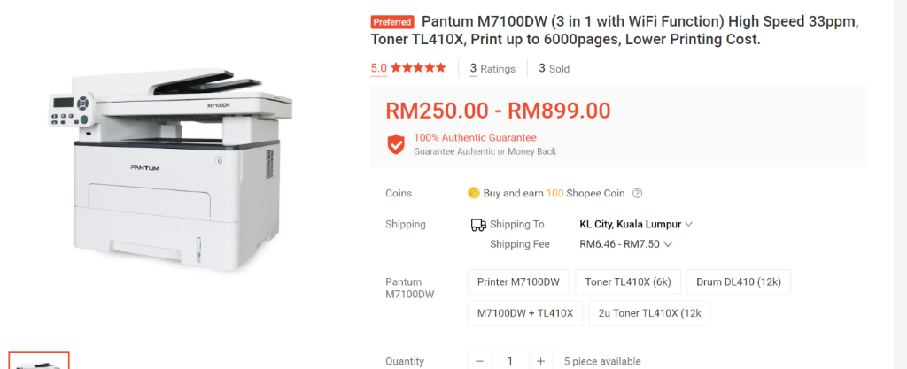

Figure 3.1.1.2 Pantum M7100DW

### **Wireless router**

TRAC had many users especially students and lecturer, so TRAC needed a strong Wi-Fi router to support the campus. It was using Wi-Fi 6, while Wi-Fi 6 (802.11ax) is the new standard that’s gradually coming into smart devices in recent years. Wi-Fi 6 has made several improvements over Wi-Fi 5 to cope with the increasing demand for faster and more efficient Wi-Fi. TRAC is a big campus, so need Signal that have high penetration. In this router, HUAWEI Wi-Fi 6-enabled phones to send 6 dB stronger signals back to AX3 in stable, 2 MHz narrow bandwidth using Dynamic Narrow Bandwidth technology, which is based on Chipset Synergy. The wireless signals can penetrate solid objects like walls and floors easily. This means that the phone will have good reception of the Wi-Fi signal even when connecting from upstairs or somewhere far from the router. Multiple Connections was what TRAC needed for. You can connect a multitude of devices to AX3 with greater efficiency. Supporting OFDMA multi-user technology, it is capable to send data to multiple devices simultaneously (max. 4 devices on 2.4 GHz, max. 16 devices on 5 GHz). The highly powered quad-core Gigahome CPU also ensures smooth running of the processor. It is capable of connecting up to 128 devices overall on dual bands. No matter how crowded the space, it will serve different users and devices promptly.

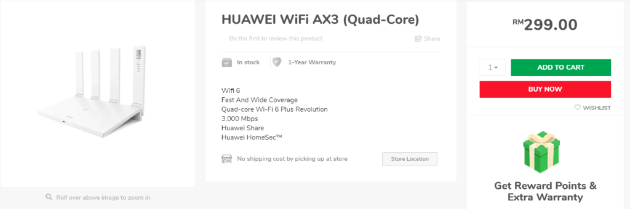

Figure 3.1.1.3 HUAWEI WI-FI AX3

### **Ethernet router**

RJ45 Cat6 (Cat6a) network patch cable from our value range. 20m length, and with RJ-45 connectors at both ends. UTP (Unshielded Twisted Pair) technology, blue color.   
Great value cable, suitable for use as a patch or standard ethernet LAN 10/100 Base-T network cable. With RJ-45 male connectors at both ends. Complies with Cat6 specifications.

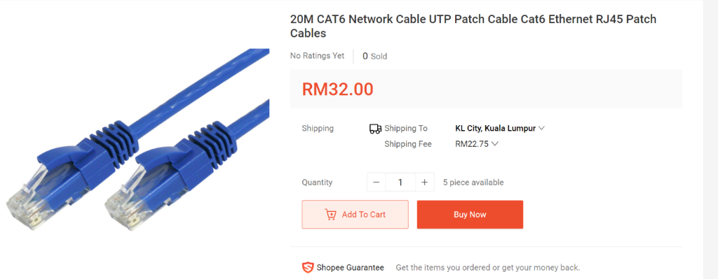

Figure 3.1.1.5 Ethernet Cable

### **Ethernet switch**

D-Link 8-Port Gigabit Desktop Switch is an economical, plug-and-play networking switch solution for SOHO and small and medium businesses that seek to benefit from the increased bandwidth of Gigabit Ethernet. It provides five/eight Gigabit ports that enable you to easily expand your network and provide a quick way to upgrade your network to Gigabit connectivity. Rounding out the feature list are Quality of Service (QoS) support and Energy Efficient Ethernet (EEE) for smoother performance and cost savings. D-Link giving fast and smooth networking. Featuring QoS, the D-Link prioritizes network traffic by type so that time sensitive data is delivered efficiently, even during bursts of high data traffic.  Additionally, the D-Link features a Kensington Security Slot on the rear panel where users can fasten the unit to a shelf or desk so the device won’t be accidentally moved or stolen. The 5/8-Port Gigabit Desktop Switch Features D-Link’s Green Technology to save energy and reduce heat, which in turn extends product life without sacrificing performance or functionality. The switch supports IEEE 802.3az Energy-Efficient Ethernet (EEE) which cuts down on power consumption during periods of low data activity, and will proceed to put the unused port into sleep mode, saving a substantial amount of power. In addition, the switch can also save energy by detecting the length of cable connected to a port and use as little power as possible. Both of these features work together to help you save power automatically.

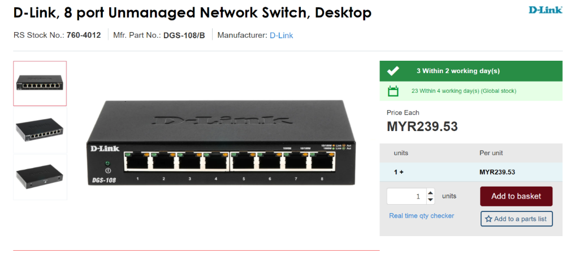

Figure 3.1.1.6 D-Link

### **Desktop**

Whether it's for entertainment, video calls, or work, the stunning Idea Centre AIO 3i will look great in any room. And with its elegant base and stand, this 21.5-inch all-in-one takes up less desk space than you think. It also makes light work of everything, TRAC lecturer and tutor need them to work. The Idea Centre AIO 3 runs like a dream—even with heavy workloads. With its AMD Ryzen™ processer and solid-state drive, it performs smoothly and quickly. It also has the option of 1TB of disk space. The Idea Centre AIO 3 delivers an exceptional viewing experience. The near-borderless 21.5-inch FHD display can also be viewed from wide angles, perfect for sharing or watching something with lecturer and student. By opting for a touchscreen, you can click or drag files directly on the Idea Centre AIO 3's screen. Lecturer also enjoy opening apps, looking at power point, and navigating your way around more intuitively. When you hook up other devices to a PC, things can get very messy. Not so with the Idea Centre AIO 3. It has a built-in cable collector in the stand, so you can have a better organized, clutter-free desk. When it comes to your other PC essentials, such as a gaming keyboard and soundbar, the Idea Centre AIO 3 can accommodate the lot. In addition to USB 2.0 and 3.0 ports, it has a 3-in-1 card reader and an HDMI slot for when you need a second screen. Whether Lecturer doing or discuss, lecturer can tilt the stand on Idea Centre AIO 3 to the perfect angle. Lecturer can also easily adjust the display to avoid any unwanted light reflection. That’s why each Idea Centre AIO 3 is fitted with a True Block Privacy Shutter. When you’re done with your webcam, just flick the button on the top of your screen to close it—and keep the outside world out.

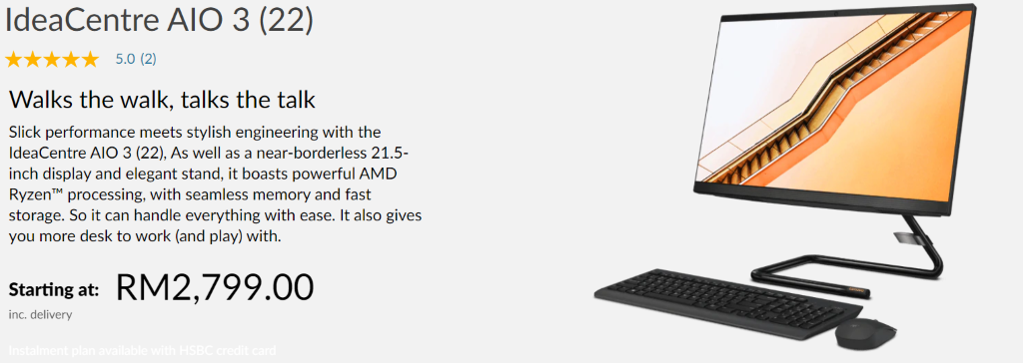

Figure 3.1.1.7 Idea Centre AIO 3

## 3.1.2 Software Cost

|  |  |  |  |
| --- | --- | --- | --- |
| **Software** | **Unit Price (RM)** | **Quantity** | **Total Price (RM)** |
| Security software (Norton Antivirus) | 129 / year | 10 | 1,290 |
| Database software (Microsoft access) | 750 | 10 | 7,500 |
| Operating system (Windows server 2019) | 4,905 | 10 | 49,050 |
| Subtotal | | | 57,840 |

### **Security software (Norton Antivirus)**

TRAC choose Deluxe plan. This company was getting the world’s leading cyber security solution from Norton. Device security also the option to choose it. TRAC always needed cloud backup to backup student's data. It was prepared with cloud backup - 75 GB3,11. Password Manager can help TRAC to protect those data. Norton also can online threat protection and virus protection promise2. Norton was giving smart firewall to given protect to TRAC, firewall always prepare to University and business. During this period, TRAC lecturer cannot f2f teach students, so they need safe cam for PC11 and keep lecturer's file protected.

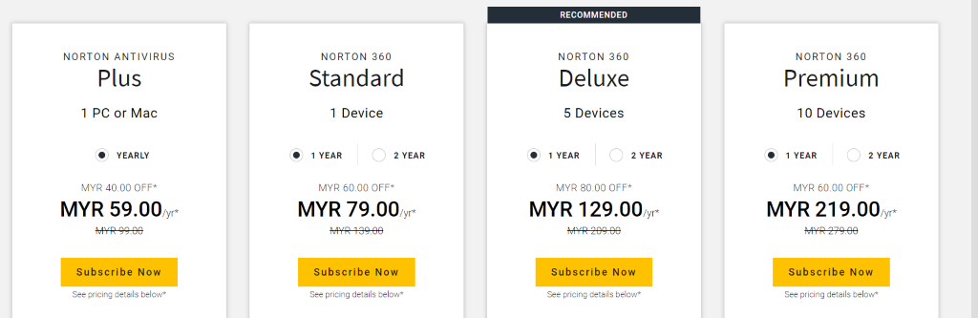

Figure 3.1.2.1 Norton Antivirus

### **Database software (Microsoft access)**

TRAC was an Education college in Malaysia. Microsoft Access was the most important in College life especially doing assignment period. Student can create and share apps without being a developer. Access is an easy-to-use tool for creating business applications. Access can help you create appealing and highly functional applications in a minimal amount of time. Access also can help TRAC to customize apps to grow with College business and student assignment. Access can easily edit as needed to meet evolving needs. Using Visual Basic for Applications, automate business processes and create more useful forms and reports. It also can integrate with multiple data sources. For example, integrate data between Access and line-of-business apps using the Access connector library to generate aggregated visuals and insights in the familiar Access interface. Easily store data in SQL Server and Microsoft Azure SQL to enhance reliability, scalability, security, and long-term manageability.

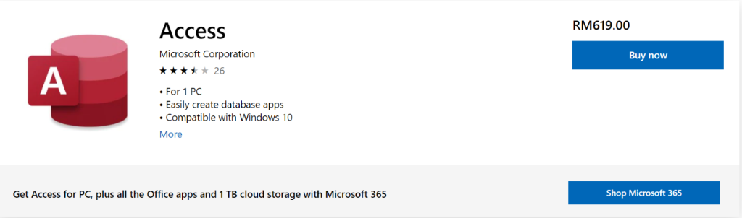

Figure 3.1.2.2 Microsoft access

### **Operating system (Windows server 2019)**

TRAC was choose windows operating system because window was the more safety and quality better. Hybrid capabilities with Azure can extend your datacenter to Azure to maximize campus investments and gain new hybrid capabilities. TRAC needed multilayer security to protect campus data. It can elevate campus security posture by protecting the datacenter, starting with the operating system. For IT department and Library department, they needed faster innovation of application and unprecedented hyperconverged infrastructure. Window Admin Centre manage campus servers, clusters, hyperconverged infrastructure and Windows 10 PCs with this browser-based app. Windows Migration Centre can make lecturer and students easier to remove or move files to another destination.

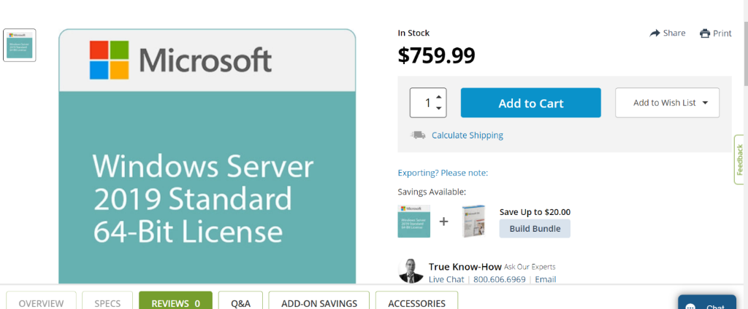

Figure 3.1.2.3 Windows Server 2019

## 3.1.3 Software Development

|  |  |
| --- | --- |
| **Software Development** | **Price (RM)** |
| Coding | 800 |
| System analysis | 2,000 |
| Feasibility studies | 2,000 |
| Subtotal | 4,800 |

## 3.1.4 Implementation

|  |  |  |
| --- | --- | --- |
| **Implementation** | **Quantity** | **Price (RM)** |
| Ethernet cables installation | 20 | 1,000 |
| New server installation | 2 | 500 |
| Desktop installation | 30 | 1,500 |
| Subtotal | | 3,000 |

## 3.1.5 Operating Cost

|  |  |  |
| --- | --- | --- |
| **Operating** | **Price / month (RM)** | **Price / year (RM)** |
| Hardware maintenances | 2,000 | 24,000 |
| Electricity | 600 | 7,200 |
| Subtotal | | 31,200 |

## 3.1.6 Cost Summary

|  |  |
| --- | --- |
| **Cost Summary** | **Subtotal (RM)** |
| Hardware Cost | 122,400 |
| Software Cost | 57,840 |
| Software Development | 4,800 |
| Implementation | 3,000 |
| Operating Cost | 31,200 |
| Total | 219,240 |

## 3.2 Benefits Summary

|  |  |  |  |
| --- | --- | --- | --- |
| **Benefits** | **RM / Month** | **Person** | **Total (RM) / year** |
| Eliminate overtime | 4000 | 4 | 192,000 |
| Eliminate additional position | 6000 | 2 | 144,000 |
| Eliminate daily errors | 150 | - | 1,800 |

## 3.3 Intangible Benefits

### **Enhanced User Experience**

By purchasing servers and routers, the user experience will be greatly improved. This is because the improvement of servers and routers will make our system more capable of carrying a large number of users to browse at the same time without affecting the user experience. This improvement will reduce the time required to complete the whole process from user request to user response, hence the system will have a faster response time.

### **Stronger System Security**

Antivirus is essential to system security. By purchasing Norton Antivirus, developers can greatly improve the security of their system. This will prevent the user's information from leaking and also ensure the security of the user's information. This will also make users more trust in the system. A good antivirus software will also automatically help users make a backup regularly to prevent data loss. This also enables users to view their own information at any time. In addition, the system can also restrict who can access the content on your system, ensuring that the system's impact on cybercriminals is minimized. System will clear all unnecessary hardware and software access rights, thereby reducing system failure points and restricting user rights to only required systems and programs.

### **Faster Response Time**

The existing system performance has improved due to the purchase of new server hardware, the entire system can handle more requests at the same time than before and the hardware allocates separate CPU cores among server computers to process student's needs. Developers will make changes to existing software to adapt to the newly purchased hardware. The software will be able to utilize the new CPU cores inside the server so these CPU cores will not be wasted and each CPU core will have fewer process to be done, thereby reducing tasks queued for processing. This improvement will shorten the time required to complete the entire process from customer’s request to customer’s response, so the system will have a faster response time.

# **Task 4: System Planning – Fact Gathering**

## 4.1 Interview Questions

|  |  |  |
| --- | --- | --- |
| **TRAC**  Q1. What do you know about the current system?  ________________________________________________________________________  Q2. Can you briefly describe how the current system works?  ________________________________________________________________________    Q3. What are the complaints about the current system?  ________________________________________________________________________    Q4. What task is the most important that you need to perform while using the current system?  ________________________________________________________________________    Q5. What problems do you face when using the borrow, return and search system of the current system?  __________________________________________________________________________    Q6. What are the benefits of using the current system?  ________________________________________________________________________    Q7. What would you do when the current system is down?  ________________________________________________________________________    Q8. How convenient is the current system which is done manually?  ________________________________________________________________________    Q9. Any function in the current system need to be changed to automatic?  ________________________________________________________________________    Q10.Do you think which function of the system is not so useful? Why?  ________________________________________________________________________    Q11. Do you think the system is relatively simple for users?  _______________________________________________________________________________    Q12. What existing function can be improved about the current system?  ________________________________________________________________________  Q13. In your opinion, what other features that can be added in the current system?  ________________________________________________________________________  **Signature:**   |  |  | | --- | --- | | Interviewee      (                     ) | Interviewer      (                     ) | |

## 4.2 Questionnaires

|  |
| --- |
| Library Requisition questionnaires |
| Purpose:  The purpose of this library requisition questionnaire is to understand the feedback and information given by students and staffs about their experience and expectations of the library service. This will help the TRAC library service to improve and for answering their needs and expectations by producing an integrated environment that will cultivate a culture of excellence in providing services. |
| **For student only**  1. How many times do you visit the library?   |  |  | | --- | --- | |  | More than five times a month | |  | Four to five times a month | |  | Two to three times a month | |  | Once a month | |  | Hardly ever |   2. Please check [**✔**] all the reasons you visit the library.   |  |  | | --- | --- | |  | Find materials for assignments | |  | Find materials for my own interests | |  | Study or do homework before school, during lunch or after school | |  | Prepare a multimedia presentation | |  | Read magazines or newspaper | |  | Information about financial aid | |  | Information about college | |  | Meet friend | |  | Other: ________________________________________________________________ |   3. How long do you need to wait in order to borrow book?   |  |  | | --- | --- | |  | 1-3 minutes | |  | 4-6 minutes | |  | 7-10 minutes | |  | Above 10 minutes |   4. How long do you need to wait in order to return book?   |  |  | | --- | --- | |  | 1-3 minutes | |  | 4-6 minutes | |  | 7-10 minutes | |  | Above 10 minutes |   5. When you search for a book, do you face any problems?   |  |  | | --- | --- | |  | No problem | |  | Take too long time to search | |  | Can’t find the book I want | |  | Other: ________________________________________________________________ |   6. Do you think that the current system update will enable more students to come to the library and even borrow books?   |  |  | | --- | --- | |  | Yes | |  | No | |  | Reason: _______________________________________________________________ |   7.How do you return the book?   |  |  | | --- | --- | |  | Return book at the counter | |  | Automatic return | |  | Other: _____________________________________ | |
| **For staff only**  8. Rate how satisfied are you with the current system.   |  |  |  |  |  |  |  |  |  |  | | --- | --- | --- | --- | --- | --- | --- | --- | --- | --- | |  | Very well |  | Good |  | Acceptable |  | Bad |  | Very bad |   9. Do you think the system is facing difficulties while processing the book, does the system complete your problem as quickly as possible?   |  |  |  |  |  |  |  |  |  |  | | --- | --- | --- | --- | --- | --- | --- | --- | --- | --- | |  | Very fast |  | Fast |  | Acceptable |  | Slow |  | Very slow |   10. Rate how easy is the system to operate. If hard, what is the problem?   |  |  |  |  |  |  |  |  |  |  | | --- | --- | --- | --- | --- | --- | --- | --- | --- | --- | |  | Very easy |  | Easy |  | Acceptable |  | Hard |  | Very hard | | Comments: | | | | | | | | | |   11. Do you think the current system processing speed achieves your expected effect.   |  |  | | --- | --- | |  | Unstable | |  | Just normal | |  | Perfect |   12. How often you have been trained to use the current system?   |  |  | | --- | --- | |  | Twice a month | |  | Once a week | |  | Others: ________________________________________________________________ |   13. What do you think about the new features added to the current system?   |  |  |  |  |  |  |  |  |  |  | | --- | --- | --- | --- | --- | --- | --- | --- | --- | --- | |  | Very useful |  | Useful |  | Normal |  | Unnecessary |  | Very unnecessary | | Comments: | | | | | | | | | |   14. How frequent is the current system to break down in a month?   |  |  |  |  | | --- | --- | --- | --- | |  | Once |  | None | |  | Twice |  | Others: _________________________ | |

# **Task 5: System Analysis – Fact Recording**

## 5.1 Context Diagram

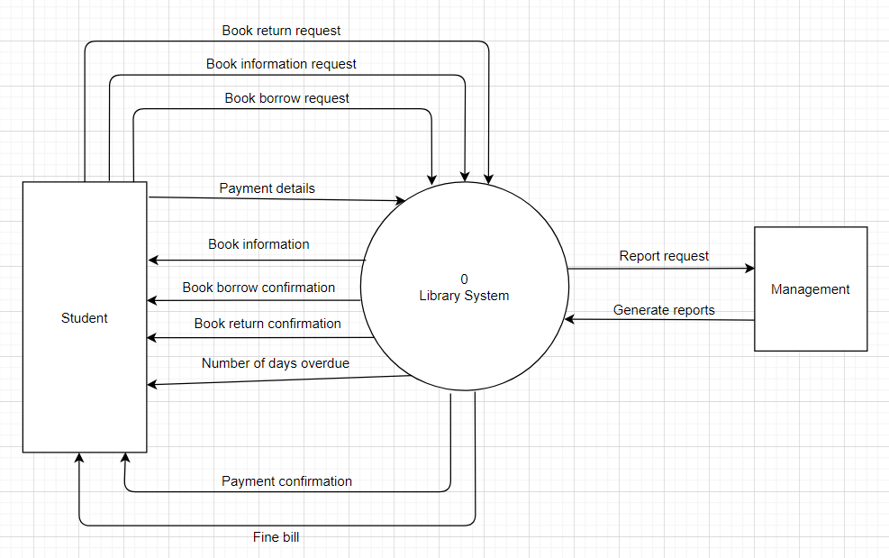

## 5.2 Diagram 0 DFD

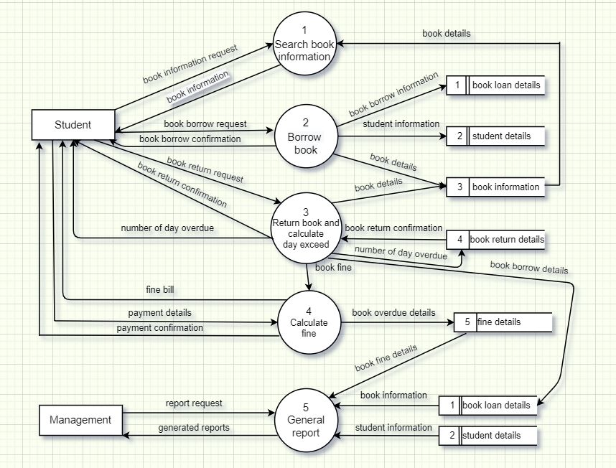

## 5.3 Diagram 1 DFD – Return book and calculate day exceed

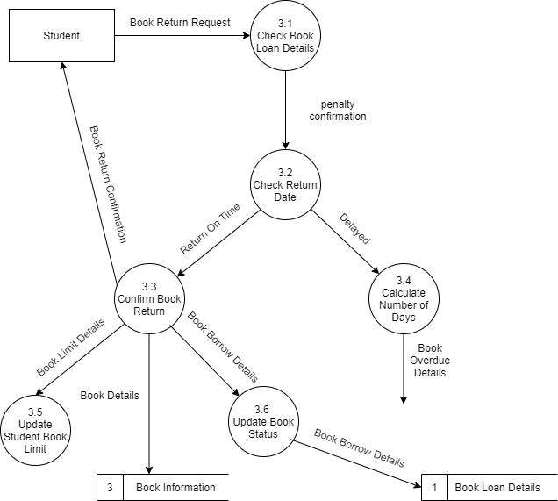

## 5.4 Entity Relationship Diagram (ERD)

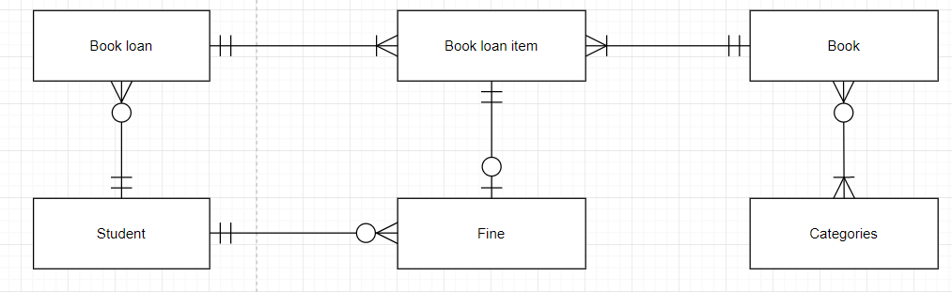

# **Task 6: System Design – Functional Design**

## 6.1 Functional Design

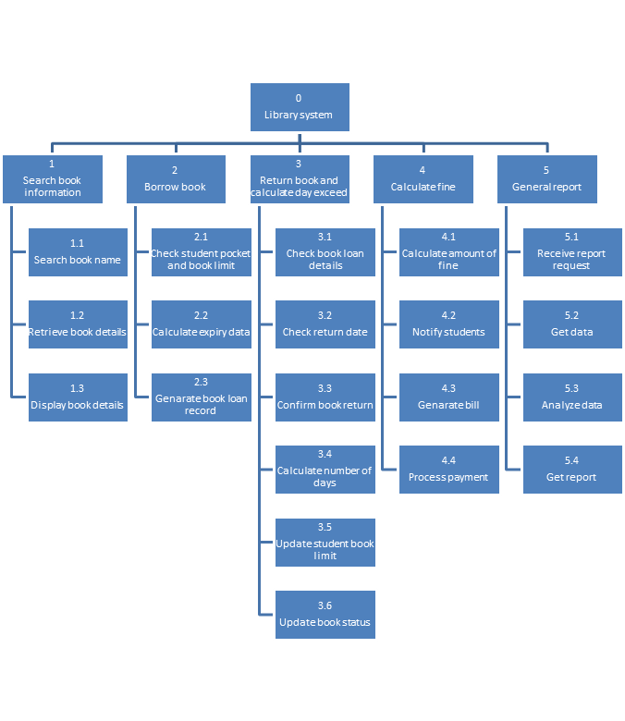

## 6.2 Functions and Features

### **3) Return book and calculate day exceed**

#### **3.1) Check Book Loan Details**

The system will check the information of borrower and the book borrowed. For example, the system needs student’s name, student’s id, book name and book details to verify the borrower of the book.

#### **3.2) Check Return Date**

After verifying the borrower and the book, the system will check whether the borrower return the book on time or over the due date.

#### **3.3) Confirm Book Return**

If the borrower returns the book on time, the system will display return confirmation successful notification to the borrower.

#### **3.4) Calculate Number of Days**

If the borrower returns the book over the due date, the system will calculate number of days exceed and transfer the book overdue details to another process to calculate the fine.

#### **3.5) Update Student Book Limit**

For every returning process done, the system will update the borrower book limit. For example, a student can only borrow 5 books on hand, so when a book is returned, the system will add 1 book limit for the student.

#### **3.6) Update Book Status**

Assume that a business book is borrowed, other students will no longer to borrow the book until the book is returned so after a particular book is returned, the system will update the availability of the book so another student can borrow the book.

### **4) Calculate fine**

#### **4.1) Calculate amount of fine**

The system will calculate the amount of fine for the borrower who late to return a book according to the amount of day exceed from the due date.

#### **4.2) Notify students**

After the fine is calculated, students will be notified the amount of the fine that need to pay.

#### **4.3) Generate Bill**

Payment bill will also give to student after generated and will state the amount of fine that need to pay including the due date of payment.

#### **4.4) Process payment**

Students will need to give students details and payment bill to make payment for the system to process the payment. When the fine is returned successfully, the system will return the successful payment confirmation to the student.

# **Task 7: System Design – Inputs**

## 7.1 Data input screen

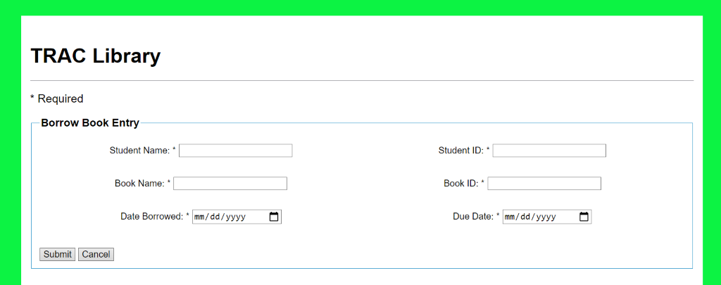

Diagram 7.1.1 Data input screen of borrow book process

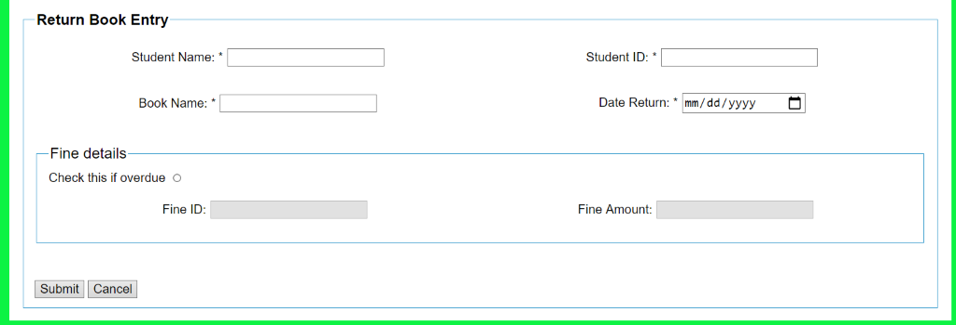

Diagram 7.1.2 Data input screen of return book process (without fine process)

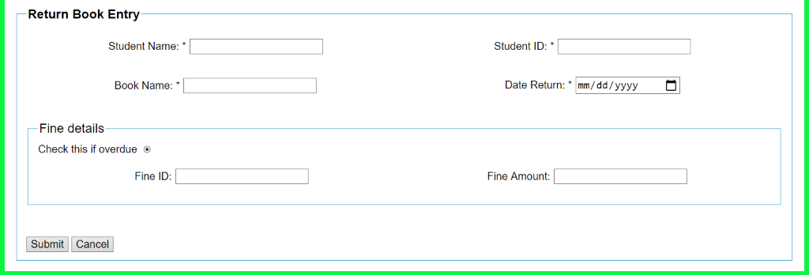

Diagram 6.1.3 Data input screen of return book process (with fine process)

## 7.2 Characteristics of user-friendly interface

### **Ease of data entry**

Based on this input screen design, all the places that need to be input are white as the background color. Therefore, users can easily see the places where to insert data. In addition, all the place that need to be input also got labels beside their input areas and this will let users more understand what should be put inside each input area. So, it will save a lot of time and the users makes less error.

### **Escapability**

This function allows users to cancel the completed input while the users decide to change their decision. In this case, users can use this button to clear all data inputted and this will let users do not waste too much time to delete the input one by one. So, users can have more experience.

### **HELP Facilities**

Based on this input screen design, users can easily search for the books they want to find through search bar. If the book has not been borrowed, the user can also directly choose to borrow the book in the system. In this way, users can borrow books without going to the library, and they don't have to worry about the books being borrowed when they go to the library.

### **Meaningful Error Messages**

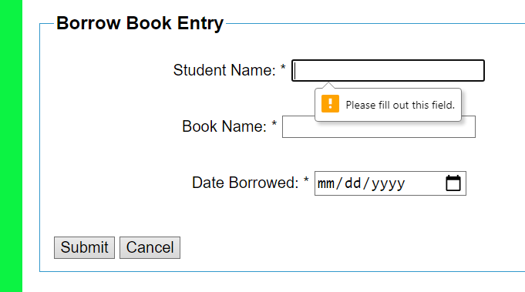

Diagram 7.2.1 Empty student name input

When users finished key in the form and press submit button, they unknowingly make mistake in the input or forget to key in required data fields. Therefore, the system will stop further processing and show error messages instead to notify the users.

## 7.3 Validation Check

|  |  |  |  |
| --- | --- | --- | --- |
| **Field** | **Validation check** | **Description** | **Remark / Example** |
| Student Name | Data Type Check | To check the data input is followed by the require data type. | Student Name must be only alphabets and same ordering as personal IC.  For example:  HO JING XIAN (valid)  HO JX / HJX (invalid) |
| Student ID | Format Check | To check the input whether it is in correct format or not. | Student ID must contain dashes ‘-’ with the format AA-BBBCCC while A is the year of the student intake, B is the first letter for each part of student name, C is the student number.  For example:  20-TKH069 (valid) |
| Book Name | Data Type Check | To check the data input is followed by the require data type. | Book name must be only alphabets or number for some particular books​​.  For example:  Tom and Jerry (valid)  Tom & Jerry (invalid) |
| All required input fields | Null Value Check | To check for not leaving any blank area. | An error message will display and not be able to continue the process if one of the required input field is empty. |
| Book ID | Format Check | To check the input whether it is in correct format or not. | Book ID must follow the format of AAAAA without spaces while A only denotes numbers.  For example: 26648 |
| Size Check | To check the data input is contained by certain number of characters. | A book ID must only contain 5 numeric numbers without spaces or any other letters.  For example: 26648 |
| Date Borrowed | Format Check | To check the input whether it is in correct format or not. | Date borrowed will be input by its format mm/dd/yyyy while ‘m’ stands for month, ‘d’ stands for day and ‘y’ stands for year.  For example: 08/26/2020. |
| Due Date | Due date will be input by its format mm/dd/yyyy while ‘m’ stands for month, ‘d’ stands for day and ‘y’ stands for year. For example: 08/30/2020. |
| Date Return | Date return will be input by its format mm/dd/yyyy while ‘m’ stands for month, ‘d’ stands for day and ‘y’ stands for year. For example: 08/31/2020. |

# **Task 8: System Design – Data Definition**

## 8.1 Attributes and Keys

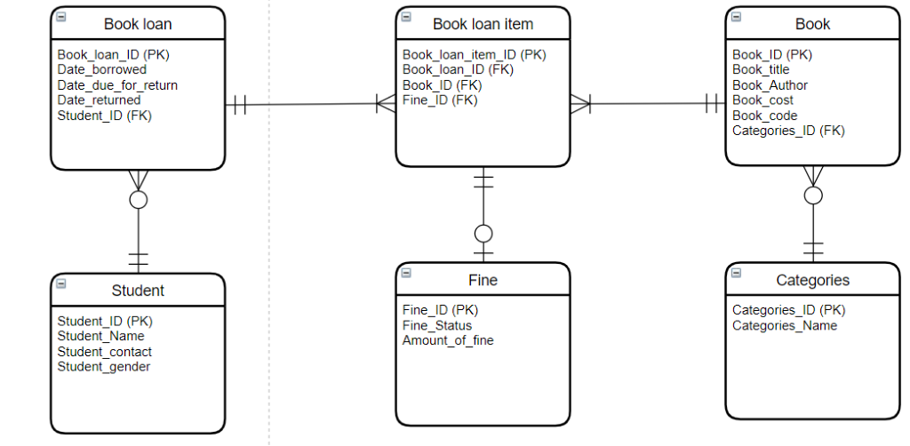

## 8.2 Develop Database Design Language (DBDL)

**Book Loan**

(Book_loan_ID, Date_Borrowed, Date_due_for_return, Date_returned, Student_ID*)

**Book Loan Item**

(Book_loan_item_ID, Book_loan_ID*, Book_ID*, Fine_ID*)

**Book**

(Book_ID, Book_title, Book_Author, Book_cost, Book_Code, Categories_ID*)

**Student**

(Student_ID, Student_Name, Student_contact, Student_gender)

**Fine**

(Fine_ID, Fine_Status, Amount_of_fine)

**Categories**

(Categories_ ID, Categories_Name)

# **Task 9: System Design – Database**

## 9.1 Code Design

### **Book loan entity – Book_loan_ID**

**Code design: Significant Alphabetic Code and Sequence Code**

|  |
| --- |
| Example |
| LOID 00001 |

|  |  |
| --- | --- |
| Loan code | Loan number |
| LOID - loan id | 00001 |

Code 1: **Book_loan_ID**

This is the code design for the primary key (**Book_loan_ID**) in Book loan entity. For example, significant alphabetic code (LOID) means loan id and sequence code (00001) means the serial No. of loan.

### **Book loan item entity – Book_loan_item_ID**

**Code design: Significant Alphabetic Code and Sequence Code**

|  |
| --- |
| Example |
| LOIT 00002 |

|  |  |
| --- | --- |
| Loan code | Loan number |
| LOIT – loan item | 00002 |

Code 2: **Book_loan_item_ID**

This is the code design for the primary key (**Book_loan_item_ID**) in Book loan item entity. As an example, significant alphabetic code (LOIT) means loan item and sequence code (00002) means the serial No. of loan item.

### **Book entity – Book_ID**

**Code design: Significant Alphabetic Code and Sequence Code**

|  |
| --- |
| Example |
| LOIT 00002 |

|  |  |
| --- | --- |
| Loan code | Loan number |
| LOIT – loan item | 00002 |

Code 3: **Book_ID**

This is the code design for the primary key (Book_ID) in book entity. For example, significant alphabetic code (BO) means book and sequence code (00003) means the serial No. of book.

### **Student entity – Student_ID**

**Code design: Derivative Code**

|  |
| --- |
| Example |
| 20DPM256 |

|  |  |  |
| --- | --- | --- |
| Student code | Course | Student number |
| 20 – year of student intake | DPM – Diploma | 256 |

Code 4: **Student_ID**

This is the code design for the primary key (**Student_ID**) in student entity. As an example, derivation code (20) means year 2020 of the student intake, (21) means year 2021. For code (DPM) means diploma course is took by the student, it can also change as (DG) for degree or (MT) for master course. For code (256) means number 256th students in this course.

### **Fine entity – Fine_ID**

**Code design: Significant Alphabetic Code and Significant Digit Code**

|  |
| --- |
| Example |
| FN 05777 |

|  |  |
| --- | --- |
| Fine code | Fine number |
| FN – fine | 05777 |

Code 5: **Fine_ID**

This is the code design for the primary key (**Fine_ID**) in fine entity. As an example, significant alphabetic code (FN) means fine and significant digit code (05777) 05 means the month of getting fine and 777 means 777th student.

### **Categories entity – Categories_ID**

**Code design: Significant Alphabetic Code and Sequence Code**

|  |
| --- |
| Example |
| C-110 |

|  |  |
| --- | --- |
| Fine code | Fine number |
| C – categories | 110 |

Code 6: **Categories_ID**

This is the code design for the primary key (**Categories_ ID)**in categories entity. As an example, significant alphabetic code (C) can be replaced by other alphabet of categories. For example, (H) is Horror, (F) is Fantasy, (A) is Adventure and etc. For sequence code (110) means the sequence of categories.

## 9.2 Data Records

### **Book loan table**

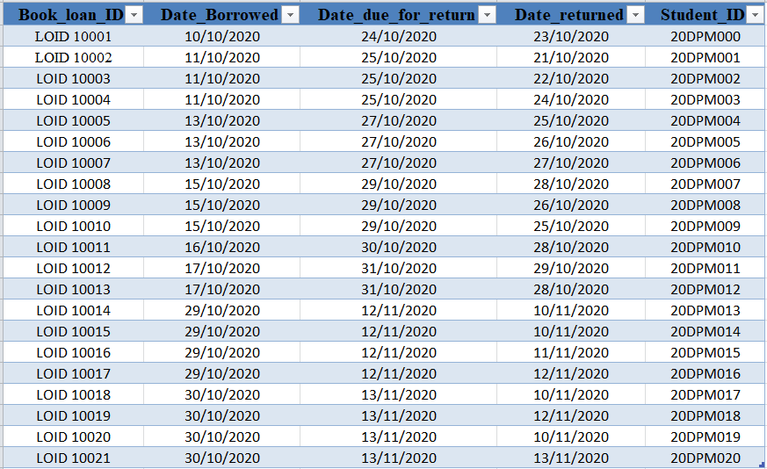

### **Student table**

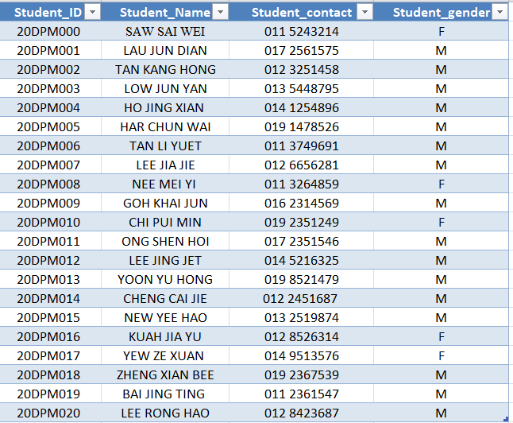

### **Book loan item**

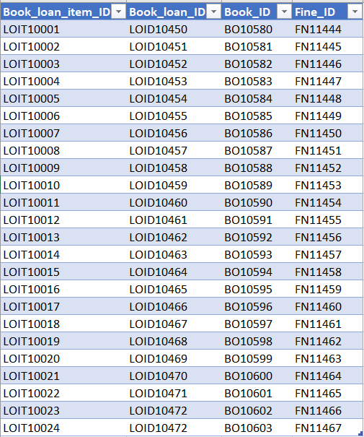

### **Fine**

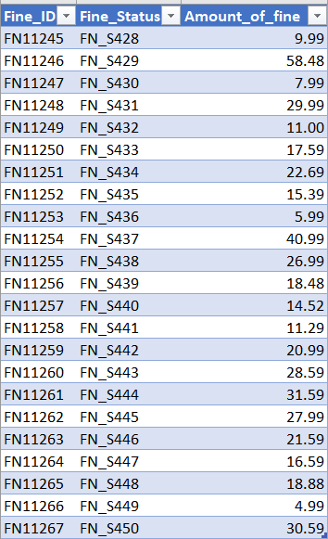

### **Book**

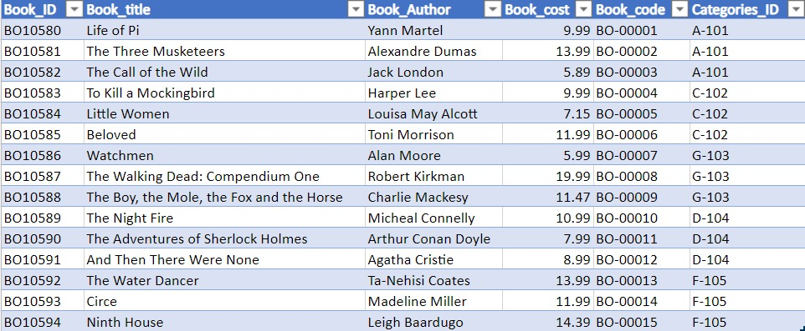

### **Categories**

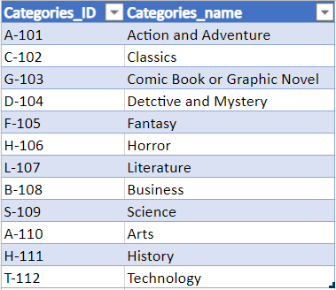

## 9.3 Database Design

### **Book loan**

|  |  |  |  |  |  |
| --- | --- | --- | --- | --- | --- |
| **No.** | **Field Name** | **Field Type** | **Length** | **Format** | **Remark** |
| 1 | Book_loan_ID | character | 9 | LOID 00001 | Primary Key |
| 2 | Date_Borrowed | date | 8 | dd/mm/yyyy | - |
| 3 | Date_due_for_return | date | 8 | dd/mm/yyyy | - |
| 4 | Date_returned | date | 8 | dd/mm/yyyy | - |
| 5 | Student_ID | character | 8 | 20DPM256 | Foreign Key |

### **Book loan item**

|  |  |  |  |  |  |
| --- | --- | --- | --- | --- | --- |
| **No.** | **Field Name** | **Field Type** | **Length** | **Format** | **Remark** |
| 1 | Book_loan_item_ID | character | 9 | LOIT 00002 | Primary Key |
| 2 | Book_loan_ID | character | 9 | LOID 00001 | Foreign Key |
| 3 | Book_ID | character | 7 | BO 00003 | Foreign Key |
| 4 | Fine_ID | character | 7 | FN 05777 | Foreign Key |

### **Book**

|  |  |  |  |  |  |
| --- | --- | --- | --- | --- | --- |
| **No.** | **Field Name** | **Field Type** | **Length** | **Format** | **Remark** |
| 1 | Book_ID | character | 7 | BO00003 | Primary Key |
| 2 | Book_title | character | 50 | A (50) | - |
| 3 | Book_Author | character | 30 | A (30) | - |
| 4 | Book_cost | number | 4 | 99.99 | - |
| 5 | Book_code | character | 7 | BOC-100 | - |
| 6 | Categories_ID | character | 5 | C-110 | Foreign Key |

### **Student**

|  |  |  |  |  |  |
| --- | --- | --- | --- | --- | --- |
| **No.** | **Field Name** | **Field Type** | **Length** | **Format** | **Remark** |
| 1 | Student_ID | character | 8 | 20DPM256 | Primary Key |
| 2 | Student_Name | alphabet | 50 | A (50) | - |
| 3 | Student_contact | number | 10 | 0123456789 | - |
| 4 | Student_gender | character | 1 | M / F | - |

### **Fine**

|  |  |  |  |  |  |
| --- | --- | --- | --- | --- | --- |
| **No.** | **Field Name** | **Field Type** | **Length** | **Format** | **Remark** |
| 1 | Fine_ID | character | 9 | FN 05177 | Primary Key |
| 2 | Fine_Status | character | 7 | FN-S100 | - |
| 3 | Amount_of_fine | number | 3 | 9.99 | - |

### **Categories**

|  |  |  |  |  |  |
| --- | --- | --- | --- | --- | --- |
| **No.** | **Field Name** | **Field Type** | **Length** | **Format** | **Remark** |
| 1 | Categories_ID | character | 5 | C-110 | Primary Key |
| 2 | Categories_Name | alphabet | 50 | A (50) | - |

# **Task 10: System Design – Outputs / Reports**

## 10.1 Table of Reports

|  |  |  |  |  |
| --- | --- | --- | --- | --- |
| **No.** | **Report Title** | **Report Content** | **User** | **Purpose** |
| 1 | Detail Report  Book Borrowed Report on Month November 2020 | The report will show the book borrow details and its quantity such as borrow date, borrower ID, book name, book category and quantity of book being borrowed. | Library Staff | This report is to know which type of books are more popular as a reference to buy new books. |
| 2 | Exception Report  Top 5 Book’s Category borrowed on first weekly November 2020 | The report will show the 5 most popular categories of book and its amount borrowed by students. | Purchasing Manager | This report is to know which book is the most popular to add on the amount of stock or buy new book that have similar categories. |
| 3 | Summary Report  Total Book Loan of Month January 2020 | This report will show the amount of book loan of January and the details of book borrowed. | Library Manager | The manager can find out the fines that students pay for each month and determine whether to increase the fines if students always return books late so that the books are always in inventory instead of being lent. |

## 10.2 Detail Report

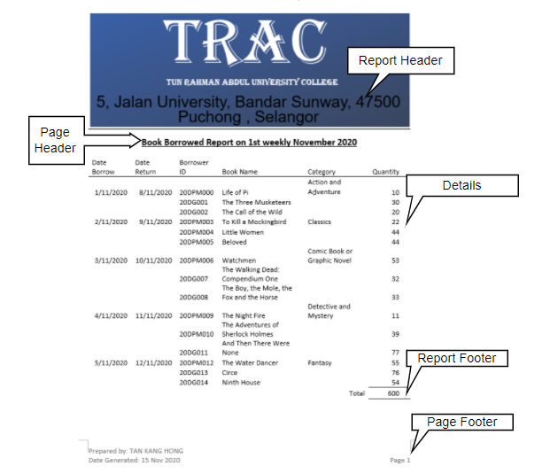

## 10.3 Exception Report

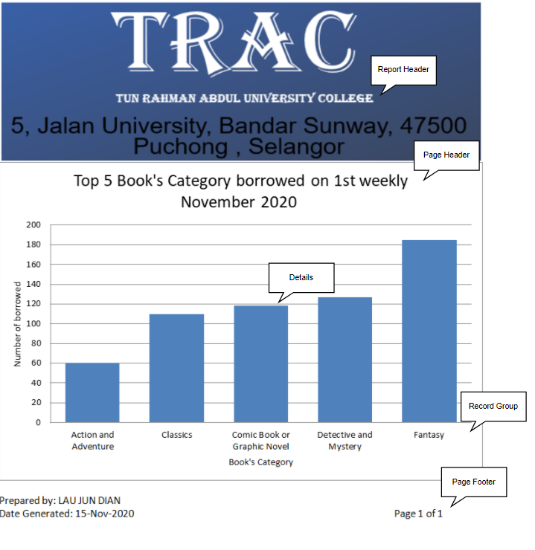

## 10.4 Summary Report

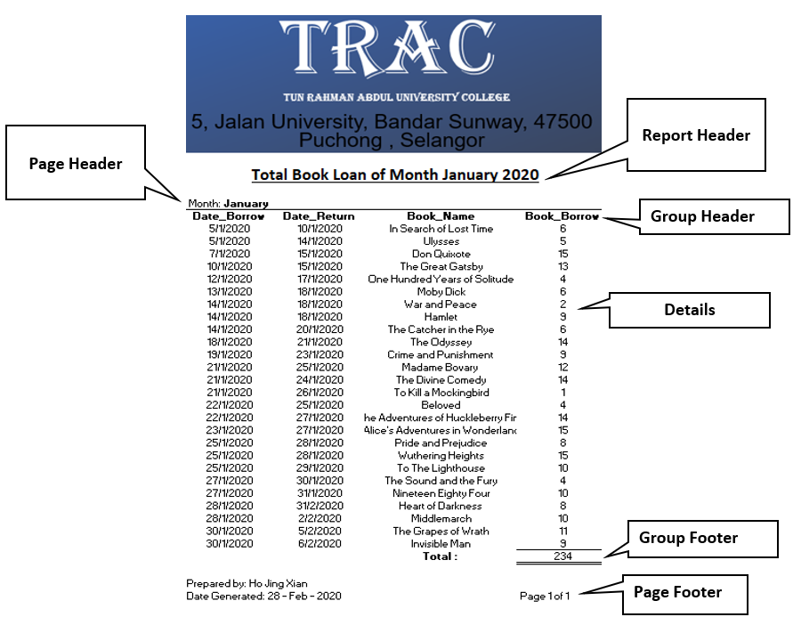

## 10.5 Principles of Good Report Design

### **1) Useful Content of the Report**

The content of the report is clear, neat and organized. This making the readers easy to understand when viewing the report. For example, the exception report uses a bar graph method to obtain information about the top 5 book’s category borrowed by students in 2019 and the total number of books, so managers can accurately understand the best types of books being borrowed by students and make their decision when purchasing new books.

### **2) Meaningful Report Titles**

The name of the report title is short but clear to express the meaning that related to the report provided. For example, the exception report shows that the title of the exception report is “Top 5 Book’s Category Borrowed by students 2019”. This title is very easy to understand by using simple yet easy words to describe about what the exception report provided. To further make the report better and clearer, the report title is specially considered that the report title will not be too long for the readers to focus on what the report shown.

### **3) Simple Layout of Report**

The layout design of report is suitable and not too complicated for the managers to read. For example, the summary report does not combine all the information into a dense report, but separates the report details by month.

### **4) Useful Headers of Report**

The report not only provides good information, but also provides useful header for information. For instance, in detail report and summary report, information is classified and sorted according to related fields (for example, date, borrower ID, etc.), so as long as they quote the required category at any time, managers can find the information they need without wasting any time.

# **References**

1. Study Malaysia. 2020. Tunku Abdul Rahman University College (TARUC). [online][Accessed 30 October 2020]

Available at: <https://studymalaysia.com/where/profile.php?code=taruc>

2. About TAR UC. 2020. Tunku Abdul Rahman University College. [online][Accessed 30 October 2020]

Available at: <https://www.tarc.edu.my/tarc-uc/overview/about-tar-uc/>

3. Public Library Survey Questions + Sample Questionnaire Template. 2020. QuestionPro. [online][Accessed 7 November 2020]

Available at: <https://www.questionpro.com/survey-templates/public-library-survey-template/>

4. Library Satisfication Survey. 2020. SurveyMonkey. [online][Accessed 7 November 2020]

Available at: <https://www.surveymonkey.com/r/T89R79B>

5. 2014 Library Services Faculty and Staff Survey. 2014. British Columbia Institute of Technology. [online][Accessed 7 November 2020]

Available at: <https://www.bcit.ca/files/library/pdf/bcit-2014_library-services_staff_and_faculty_survey_report.pdf>

6. 21 of the Most Popular Book Genres, Explained. 2019. The Oprah Magazine. [online][Accessed 30 November 2020]

Available at: <https://www.oprahmag.com/entertainment/books/a29576863/types-of-book-genres/>

# **Appendix**

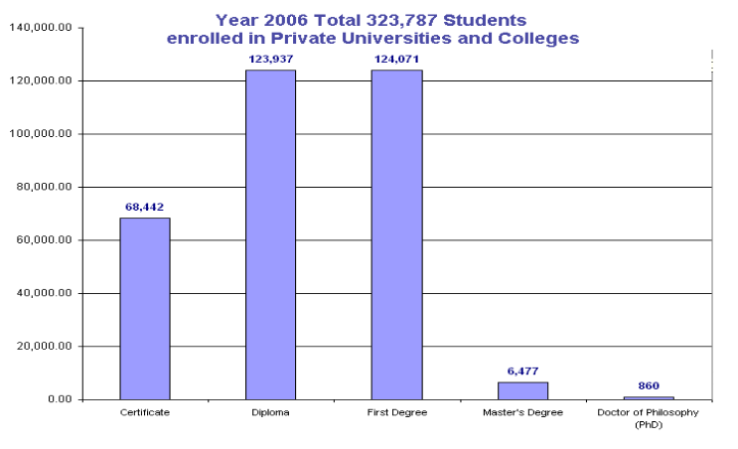

Private Universities and Colleges in Malaysia



TRAC Logo and Address

